Formulary EE
Charge and amounts of charge
Proton Charge symbol (“elementary charge”) | $$e$$
Electron charge symbol | $$-e$$
Symbol for amounts of charge (aka “charge”)  Unit of amounts of charge  Relations | $Q$: constant amount of charge  $q(t)$: time variable charge  $$[Q] = [q] = Coulomb = C$$  $$1 C=6.24∙{10}^{18}e$$  $$1 e=1.60∙{10}^{-19}C$$  $$-e=-1.60∙{10}^{-19}C$$  $$1C=1As$$
Electric current
Amount of charge  passing through a cross-section  in the indicated direction during the time | 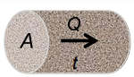  Q  A  $$t$$
Electric current magnitude (aka current), mean value  Instantaneous electric current  Unit of the electric current  Relations | $$I=Q/t$$  $$i\left(t\right)=dq(t)/dt$$  $$\left[I\right]=\left[i\right]=Ampere=\text{Amp}=A$$  $$1 A=\frac{1C}{s}$$  $$1C=1As$$  $$3600 C=1 Ah$$
Current direction
“real current (electron) direction”

“conventional direction of current”

Current density
Cross sectional area | $$A$$
Current vertical through cross-sectional area | $$I$$
Current density, mean value: | $$J=\frac{I}{A}$$
time-dependant current density  Unit of current density  Example: Copper cables | $$j\left(t\right)=i(t)/A$$  $$\left[J\right]=A/m^{2}$$  about$+5°C at 6A/mm^{2}$ (no heating)  about $+70°C at 16 A/mm^{2}$(for higher Temps)

Power and energy
Formula symbol for average power  Instantaneous power  Unit of Power |  | $$P$$  $$p(t)$$  $$\left[P\right]=\left[p\right]=Watt=W$$
Symbol for energy, from “work”  - E is reserved for electric field strength  Unit of energy |  | $$W$$  $$\left[W\right]=Joule=J$$  $$1J=1Ws=1Nm=1\frac{kg∙m^{2}}{s^{2}}$$  $$1kWh=3.6∙{10}^{6}J$$
Voltage
Definition of voltage (aka electromotive force)  “ratio of the energy released to the amount of charge transported from point A to point B”  Symbol, mean value  Time variable voltage  Unit voltage  Relations | $$U_{AB}=∆W/∆Q$$  $$→W=U∙Q=\left[V\right]∙[As or C]$$  $U$, (USA:$V)$  $$u(t)$$  $$\left[U\right]=\frac{J}{C}=Volt=V$$  $$1 V=1J/As$$
Nominal voltage = average voltage  = (Fully charged – allowable discharge)/2 | The nominal voltage allows the energy stored in a fully charged battery to be calculated, assuming a linear voltage decrease during discharge.
Resistance and Conductance
Definition of electrical resistance  Unit of resistance | $$R=U/I$$  $$U=R∙I$$  $$I=U/R$$  $$\left[R\right]=\frac{V}{A}=Ω=Ohm$$
Definition of electrical conductance  Unit of conductance: | $$G=I/U$$  $$\left[G\right]=\frac{A}{V}=S=Siemens=aka mho (US.)$$
Resistor: const. ratio between voltage and current | $$\frac{U}{I}=const$$
Specific Resistance, Specific Conductance
Specific resistance “rho”  use: calculate resistance of a wire based on its geometrical properties and $ρ$  Unit | $$ρ=\frac{A∙R}{l}$$  $$R=\frac{ρ∙l}{A}$$  $$\left[ρ\right]=Ω∙m={10}^{-6}∙\frac{Ωmm^{2}}{m}$$
Specific conductance “sigma”  Unit | $$σ=\frac{1}{ρ}$$  $$\left[σ\right]=\frac{S}{m}$$
Power
Average power | $$P=\frac{∆W}{∆t}=\frac{∆Q}{∆t}∙U$$  $$P=I∙U=R∙I^{2}=Watt$$
Instantaneous power | $$p\left(t\right)=u\left(t\right)∙i(t)$$
Kirchhoff’s laws
Mesh rule  The sum of all voltages in a mesh, taking into account the direction of the arrows, is 0. Justification: energy conservation | Node rule  The sum of all currents towards a node is equal to the sum of all currents flowing away from the node. Reason: the ideal node is a pure connecting element and therefore cannot store any charge.
Systematic error correction
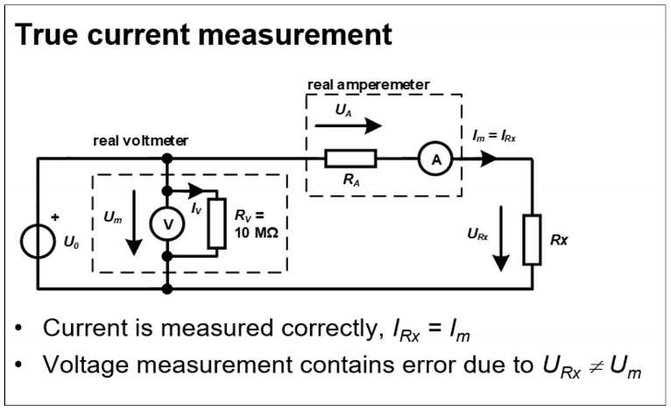 | 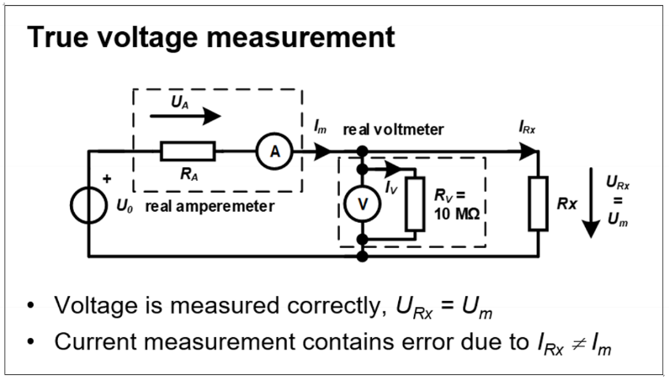
$$U_{RX}=U_{m}-U_{A}=U_{m}-I_{RX}∙R_{A}=U_{m}-I_{m}∙R_{A}$$ | $$I_{RX}=I_{m}-I_{V}=I_{m}-\frac{U_{m}}{R_{V}}$$
Ohmic Resistors
Series
Parallel
Ohmic voltage divider | Ohmic current divider
$$\frac{U_{1}}{U_{2}}=\frac{R_{1}∙I}{R_{2}∙I}=\frac{R_{1}}{R_{2}}$$  $$U_{2}=R_{2}∙I=R_{2}∙\frac{U}{R_{1}+R_{2}}=\frac{R_{2}}{R_{1}+R_{2}}∙U$$ | $$I_{2}=\frac{U}{R_{2}}=\frac{I∙(\frac{R_{1}∙R_{2}}{R_{1}+R_{2}})}{R_{2}}=\frac{R_{1}}{R_{1}+R_{2}}∙I$$  $$\frac{I_{1}}{I_{2}}=\frac{U}{R_{1}}∙\frac{R_{2}}{U}=\frac{R_{2}}{R_{1}}$$

Linear model for batteris and accumulators
«Linear voltage source» = ideal voltage source + series resistance (“Internal resistance $R_{i}$”)
$$R_{i}=\frac{U_{0}}{I_{0}}$$

Network Analysis
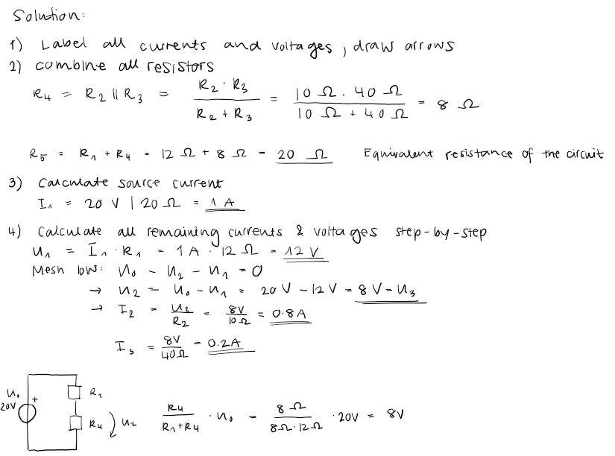
Conditions for the method (Superposition Principle)
- Linear network
  - Allowed as used elements are resistors, linear sources, (capacitors, coils)
- There is only one source in each partial solution
- The current and voltage arrows on a particular one-port must point in the same direction in all partial solutions, preferably defined at the beginning.

Superposition Principle
- all sources except 1 = 0 calculate currents & voltages
- next source to value, all others = 0 calculate currents & voltages
- add up partial solutions
- Ideal voltage source with 0V = short circuit!
- Set
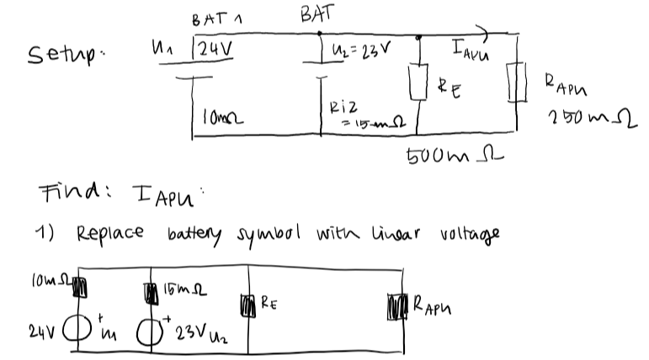
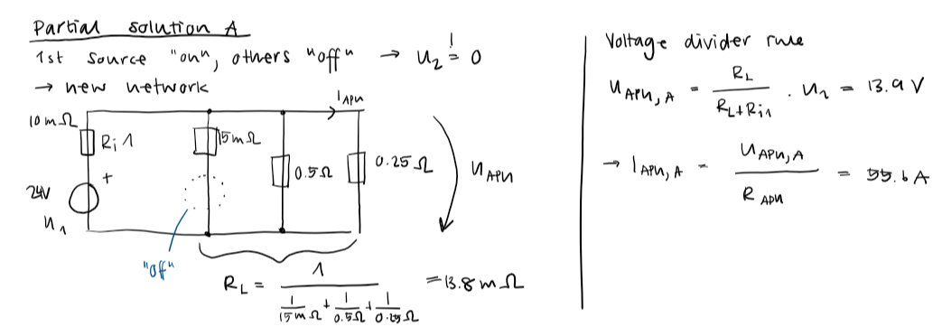
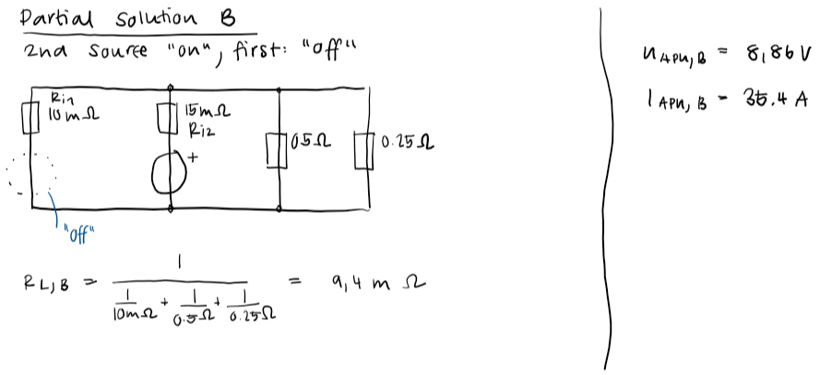
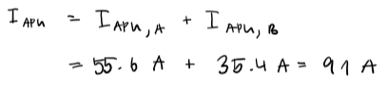

Batteries in Parallel
Paralleling batteries results in higher available currents  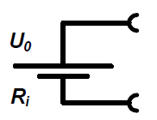  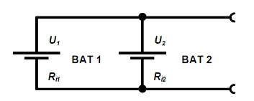 | $$U_{0}= \frac{U_{1}∙R_{i1}+U_{2}∙R_{i2}}{R_{i1}+R_{i2}}$$  $$R_{i}= \frac{R_{i1}∙R_{i2}}{R_{i1}+R_{i2}}$$  $$I_{0}=\frac{U_{1}}{R_{i1}}+\frac{U_{2}}{R_{i2}}$$
Batteries in Series
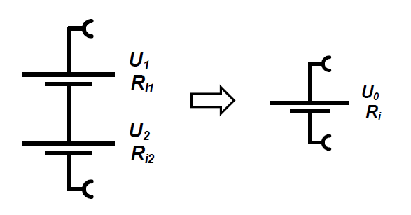 | $$U_{0}=U_{1}+U_{2}$$  $$R_{i}=R_{i1}+R_{i2}$$  $$I_{0}= \frac{U_{1}+U_{2}}{R_{i1}+R_{i2}}$$  Paralleling similar batteries results double the voltage, whereas the short-circuit current stays the same
Exercise 4 – Task 1 | Solution
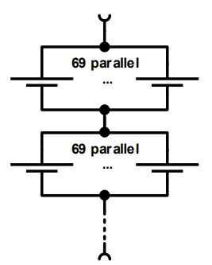  One of the first cars made by Tesla, the Tesla Roadster, used a battery bank consisting of 6831 batteries type 18650. Let us assume, all those batteries have an idle voltage of 3.7 V and an internal resistance of 100 mΩ. The batteries are connected as follows:  • Groups of 69 batteries are connected in parallel  • All these 99 groups are connected in series | Due to all batteries having the same idle voltage of 3.7 V and the same internal resistance of 100 mΩ, calculations are straightforward:  - A group of 69 batteries in parallel has an internal resistance of $100 mΩ/69 = 1.45 mΩ$ and an short circuit current of $69 ꞏ 3.7 V / 100 mΩ = 2553 A$  - All groups in series, i.e., the equivalent battery, has an internal resistance of $99 ꞏ1.45 mΩ = 143.6 mΩ$ and an idle voltage of $99 ꞏ 2553 A ꞏ 1.45 mΩ = 366.5 V$.
Temperature model for metal alloy resistors
$α_{20}$Linear Temperature coefficient (in 1/Kelvin or 1/°C)  $β_{20}$ Quadratic Temperature coeff. (in 1/Kelvin2 or 1/°C2)  $R_{20}$ Resistance value at 20 °C  Δϑ Temperature increase  Rϑ Value of resistance at the temperature ϑ of the element (possibly ≠ ambient temperature), [ϑ] =°C | Polynomial description :  $$R_{ϑ}=R_{20}∙(1 + α_{20}∙∆ϑ + β_{20}∙∆ϑ^{2})$$  If β20 is not given, you can neglect it
NTC temperature model
T Temperature in Kelvin  R Value of resistance at this temperature  R25 Nominal resistance at 25 °C  A₁,B₁,C₁,D₁ Coefficients (see datasheet) | $$T(R) = \frac{1}{A_{1}+B_{1}\ln{\frac{R}{R_{25}}+C_{1}{(ln{\frac{R}{R_{25}}})}^{2}+ D_{1}{(\ln{\frac{R}{R_{25}})}}^{3}}}$$

Magnetic Force Between Conductors
$μ$ depends on the material between the conductors, it is called “permeability” | $$F_{m}=I_{1}∙I_{2}∙+ l∙μ∙\frac{1}{2πr}=[N]$$
Permeability $μ$
Unit of permeability  Permeability of the vacuum  Permeability of any substance  Relative permeability | $$\left[μ\right]= V∙s/(Am)$$  $$μ_{0}= 4 ∙π∙{10}^{-7}\frac{Vs}{Am}$$  $$μ$$  $$μ_{r}= μ/μ_{0}$$
Magnetic Field Strength
“Magnetic field strength B1” of a long straight current I₁ at a distance r | $$B_{1}=\frac{{μ_{0}∙I}_{1}}{2πr}$$
Magnetic field strength B | Magnetic field strength H
also “magnetic flux density”, “magnetic induction”  Unit: $\left[B\right]=\frac{V∙s}{m^{2}}=Tesla=[T]$ | also “magnetic excitation”  Unit: $[H] = A/m$
Relationship: $H = \frac{B}{μ}$
Application of Magnetic Field Strengths
$$Vector length: B = \frac{μ_{0}∙I}{2πr}$$ | $$F_{M}=I_{2}∙l⋅B_{1}$$  $$F_{M}=I∙l∙ B∙ sin α$$  For an angle $α≠ 90°$
Magnetic Field Vector
Definition  For force as a vector, a current vector and a magnetic field (strength) vector is needed, and the ordinary product is converted to a cross product: | $$\vec{F_{M}}= l∙ \vec{I_{2} }×\vec{B_{1}}$$  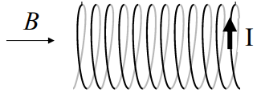
Magnetic Field Strength Inside a Coil
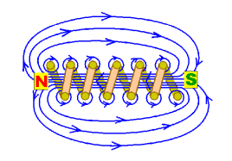  for current I,  Length ℓ,  diameter d,  Number of turns N, inside a coil | $$B = \frac{μ∙I∙N}{\sqrt{l^{2}+d^{2}}}$$  $$F_{M}= N∙I ∙l∙B$$

Magnetic flux
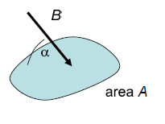  Unit of magnetic flux  B homogeneous with inclination angle $α$ referred to a flat surface A | $$[ϕ] = T∙m^{2}= Vs = Weber = Wb$$  $$ϕ=B∙A∙sin\left(α\right)$$  $$ϕ\left(t\right)=B∙A∙\cos\left(2∙π∙\frac{t}{\frac{1}{f}}\right)$$
Induced voltage
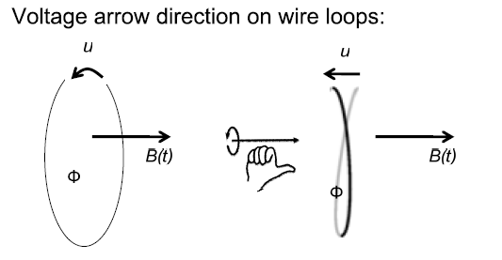 | $$u = -\frac{dϕ}{dt}$$  $$if u\left(t\right)=\frac{dϕ}{dt}=const.=u_{max}=\frac{dB}{dt}=\frac{d(B∙l∙v∙t)}{dt}=B∙l∙v$$
Linked flux
Linked flux “Psi” for coil with N turn with the flux $ϕ (magnetic flux)$ per turn [Wb] | $$ψ= N∙ ϕ$$  $$ϕ=B∙A$$
Linked voltage
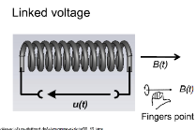  Max voltage  P: number of poles, f: frequency | $$u = - \frac{dϕ}{dt}∙N = -\frac{dψ}{dt}$$  $$max\left(u\right)=4 ∙p∙ψ_{pole}∙π∙f$$
Coil with iron core
Higher field strength  $$with μ_{r }> 300$$ | $$B = \frac{μ_{0}μ_{r}∙I∙N}{\sqrt{l^{2}+d^{2}}}$$
Eddy current | Magnetic field of the eddy current
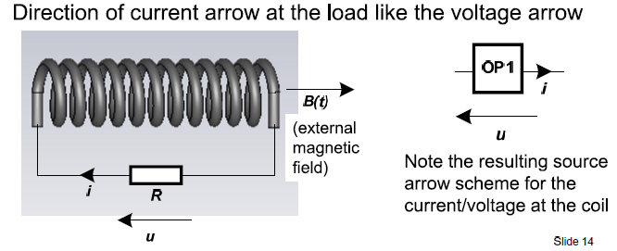  Eddy current, ideal coil without resistance connected to an ohmic resistor R in an external magnetic field B(t), causing linked flux $ψ$(t).  $$i = - \frac{dψ}{dt}/R$$ | Eddy current causes a field in the coil  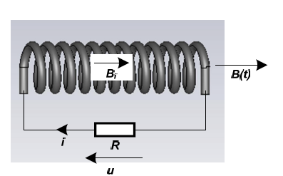  Field direction according to right-hand rule  $$B_{i} = \frac{μ∙I∙N}{\sqrt{l^{2}+d^{2}}}$$
Self induction
Unit: $\left[L\right]= Henry =\left[H\right]=[Wb/A]$  Self-induced voltage with inductance L | $$u_{L }=L∙\underset{d: Differenz}{\underbrace{\frac{di}{dt}}},ϕ= \frac{L}{N}∙i$$
Cylindrical coil
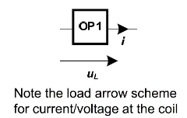  - Length l  - Diameter d  - Windings N  - Cross-sectional area A  Energy in the coil | $$L = \frac{μ_{0}μ_{r}∙A}{\sqrt{l^{2}+d^{2}}}∙N^{2}=[H]$$  $$W_{L}= \frac{1}{2}{LI}^{2}=[J]$$
Toroidal coil for thin wire
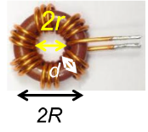  - d: Core diameter  - r: Inner radius  - R: Outer radius  - N: windings | $$L = N^{2} ∙\frac{μ_{0}μ_{r}∙d}{2π}∙\ln{\frac{R}{r}=[H]}$$
Wire resistance | $$u_{S}=L∙\frac{di}{dt}+R_{s}∙i, u_{L}=L∙\frac{di}{dt}$$
PM Motor torque
For a single loop, with current I, side length ℓ, lever arm r, magnetic field B, angle α between surface normal and magnetic field  With current I, A surface area, B magnetic field and N windings  Torque with many loops, without mechanical losses, with torque constant k_{M} | Unit of torque $[M] = Nm$  Unit of the torque constant $[kM] = Nm/A$  $$M = 2 ∙I ∙l∙B∙r∙\left|sin α\right|$$  $$M = I∙A∙B∙N$$  $$M = k_{M}∙I=[Nm]$$  $$k_{M} = \frac{M}{I}=\left[\frac{Nm}{A}\right]$$
PM Motor: Equivalent Circuit, Symbol
For the PMDC motor UBEMF= n /k_{n} with speed constant k_{n} and speed n, [n] = $\min^{-1}$= rpm  Unit of the speed constant  $$but sometimes also$$  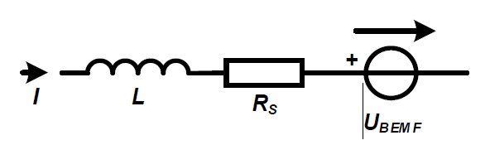 | $$U_{BEMF}= n/k_{n}$$  $$\left[k_{n}\right]=\frac{\min^{-1}}{V} =\frac{rpm}{V}$$  $$\left[k_{n}\right]=1000∙\frac{\min^{-1}}{V}$$
Motor Power
Motor Power, voltage U at motor, current I through the motor | $$P_{in}= U∙I$$
Mechanical Power (without mechanical losses)  $$ω = 2 π \frac{n}{60}$$ | $$P_{out}= M∙ω= M ∙n∙\frac{π}{30}$$
Efficiency “eta” | $$η= \frac{P_{out}}{P_{in}}$$
Relationship between the torque kM· kn= 30 / π  constant and the speed constant when mechanical losses are neglectable | $$k_{M}∙k_{n}= \frac{30}{π}$$  $$k_{n }= \frac{30}{π∙k_{M} }[rpm/v]$$
Motor Characteristics of a PMDC Motor
$$M = \frac{k_{m}}{R_{s}}∙U_{0}-n∙\frac{k_{m}}{k_{n}∙R_{s}}∙$$ | $$n = k_{n}∙U_{0}-\frac{k_{n}}{k_{m}}∙R_{s}∙M$$
Idle speed [rpm] | $$n_{0}=k_{n}∙U_{0}$$
Holding torque / stands still | $$M_{H}=\frac{k_{m}}{R_{s}}∙U_{0}$$

Capacitance
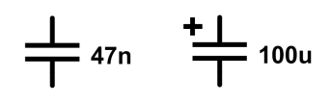  Capacitance: Two capacitors connected in series have always the same charge!  N=nano, u=my=micro  Unit  Relations to the unit: | $$C = \frac{Q_{C}}{U_{c}}$$  $$[C] = Farad = F$$  $$1 F = 1 C/V = 1 A/V$$
Charge  Charge when parallel | $$Q_{c}= C ∙U_{c}$$  $$Q = Q_{1}+Q_{2}$$
Instantaneous charge | $$q_{c}\left(t\right)=C∙u_{c}\left(t\right)$$
Instantaneous current | $$i_{c}(t)=C∙\frac{{du}_{c}}{dt}$$
Momentary voltage | $$u_{c}(t)= \frac{1}{C}\int_{t0}^{t}{i_{c}∙dt +}u_{c}(t_{0})$$
Energy in a capacitor | $$W = \frac{1}{2}{∙Q}_{c}{∙U}_{c}$$  $$W = \frac{1}{2}∙C∙U_{C}^{2}$$  $$W = \frac{1}{2}\frac{Q_{C}^{2}}{C}$$
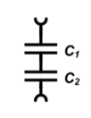  General formula for capacitors in series  2 series capacitors (only for two cap.) | $$\frac{1}{C_{tot}}=\frac{1}{C_{1}}+\frac{1}{C_{2}}$$  $$C_{tot}= \frac{C_{1}∙C_{2}}{C_{1}+C_{2}}$$
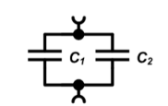  2 Parallel capacitors | $$C_{tot}=C_{1}+C_{2}$$

Dielectric strength
Dielectric strength  Unit  Flashover voltage  d: dielectric thickness  Maximum working voltage | $$E_{D}$$  $$\left[E_{D}\right]=\frac{kV}{mm}$$  $$U_{D}=E_{D}∙d$$  $$U_{Cmax}≪U_{D}$$
Coulomb’s Law, Permittivity
Attraction/repulsion force for two charged spheres at distance d (d >> sphere radius R)  Permittivity ($≠$permeability) of a material  Unit of permittivity | $$F = \frac{1}{4πε}\frac{\left|Q_{1}\right|∙\left|Q_{2}\right|}{d^{2}}$$  $$ε$$  $$\left[ε\right]=\frac{F}{m}$$
Permittivity of the vacuum | $$ε_{0}= 8.85 ∙{10}^{-12} F/m$$
Dielectric constant (“epsilon r”) | $$ε_{r}= ϵ/ε_{0} or ϵ=ε_{r}∙ε_{0}$$
Flashover voltage | $$U_{max}= dialectric strength∙thickness$$
Capacitance Formulas
Plate capacitor Distance d or thickness, area A  If two plates -> 2 windings -> multiplicate by 2 |  | $$C = \frac{εA}{d}=\frac{ε_{r}ε_{0}A}{d}$$
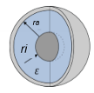  Spherical capacitor Outer radius r_{a}, Inner: r_{i}  Free standing sphere with radius r |  | $$C = \frac{4πε}{\left(\frac{1}{r_{1}}-\frac{1}{r_{a}}\right)}$$  $$C = 4πεr$$

AC |  | Bei Mix von DC und AC -> DC berechnen -> î und Û berechnen und dann weiter
Definitions about AC
Amplitude Û (maximum value), angular frequency $ω, time t, zero phase angle: φ_{u}, by convention -180°<φ_{u} ≤180°$ |  | $$u(t) = Ûcos(ωt+φ_{u})$$
Frequency f |  | $$ω = 2πf = \frac{2π}{T} [ω] =rad/s$$
Average power |  | $$P = \frac{Û∙Î}{2}$$
Instantaneous power |  | $$p(t) = u(t)∙i(t)$$
RMS value of a voltage Amplitude
 |  | $$P = \frac{Û∙Î}{2}=\frac{Û∙Û}{2∙R}= \frac{Û^{2}}{2R}=\frac{U^{2}}{R}→U=\frac{Û}{\sqrt{2}}$$
RMS voltage Û= Amplitude |  | $$U_{RMS}=\frac{Û}{\sqrt{2}}$$
RMS current (meaning root-man-squared)  Î = Amplitude |  | $$I_{RMS}=\frac{Î}{\sqrt{2}}$$
Capacitors at alternating current
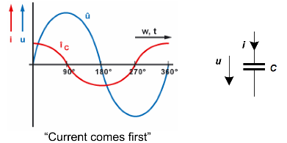 | $$i = C \frac{du}{dt}$$  $$u = \frac{1}{C}\int{i dt}$$
Ratio current/voltage at the capacitor
$Z_{c}=$"Impedance of the capacitor” (always positive, unit: Ω)  $$u(t)=Ûsin(ωt)$$  $$i(t) = Îcos(ωt)=C∙\frac{du(t)}{dt}=C∙Ûcos(ωt)∙ω$$ | $$→Î = C∙Û∙ω$$  $$→\frac{Û}{Î}=\frac{U}{I}=\frac{1}{ω∙C}$$
Coils at alternating current
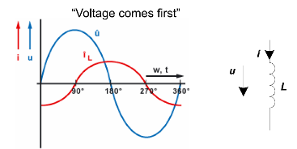 | $$u = L\frac{d}{dT}i$$  $$i = \frac{1}{L}\int{u dt}$$
Ratio current/voltage at the coil
$$Coil impedance \left(always positive, unit:Ω\right)$$  $$i\left(t\right)=-îcos\left(ωt\right)$$  $$u(t) = Ûsin(ωt) = L∙\frac{di(t)}{dt}=L∙Îsin(ωt)∙ω$$ | $$→Û=L∙Î∙ω$$  $$→\frac{Û}{Î}=\frac{U}{I}= ω∙L = Z_{L}$$
More AC quantities
Admittance | $$Y = \frac{1}{Z} [Y ] = Siemens = S$$
Capacitor reactance*  Minus sign to distinguish capacitive/inductive (convention) | $$X_{c}=-Z_{c}=-\frac{1}{ω∙C}$$
Capacitor susceptance | $${BX}_{c}=\frac{1}{Z_{c}}=-\frac{1}{X_{c}}=ω∙C$$
Coil reactance | $$X_{L}=Z_{L}=ω∙L$$
Coil susceptance | $$B_{L}= -\frac{1}{Z_{L}}=-\frac{1}{X_{L}}=-\frac{1}{ω∙L}$$
Conductance | $$G = \frac{1}{R}$$

AC Circuits and calculations series
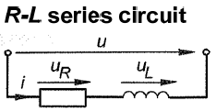 | 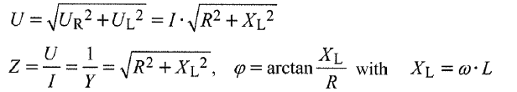
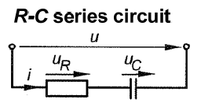 | 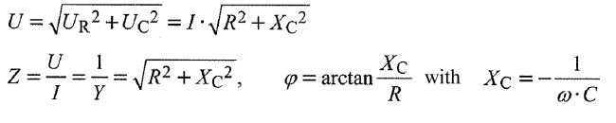
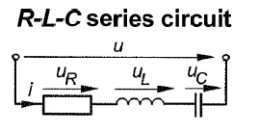 | 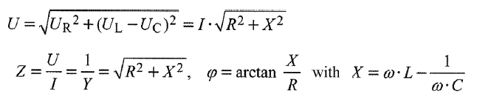
AC Circuits and calculations parallel
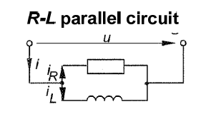 | 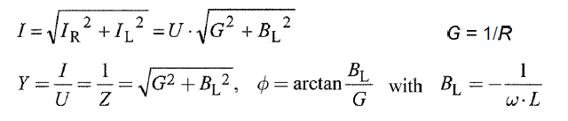
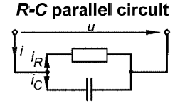 | 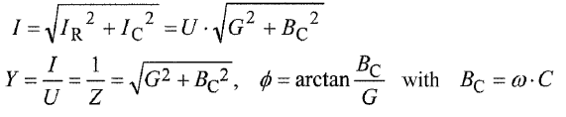
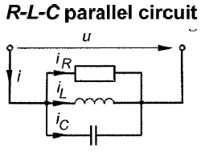 | 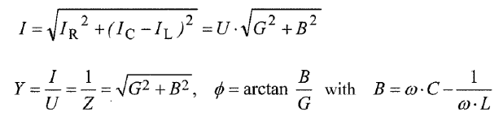

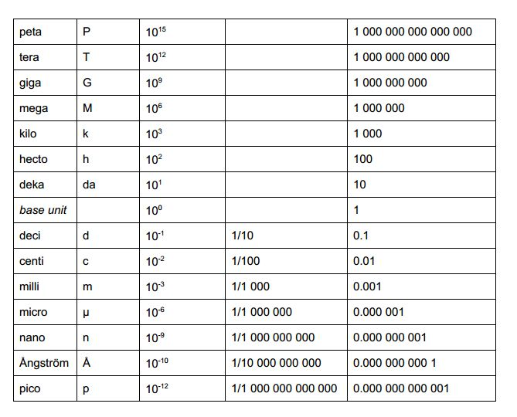
Conversion Scale Areas
Circle: $A=πr^{2}=\frac{d^{2}∙π}{4}$

Integration
$$\int_{a}^{b}{f(x)dx }=F(b)-F(a)={[F(x)]}_{a}^{b}= {F(x)|}_{a}^{b}$$
Definition
Eine Funktion $F(x)$ heisst Stammfunktion von $f(x)$, falls $F'(x) = f(x)$.
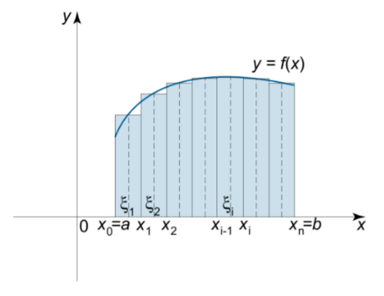
Bsp: $f(x) =x^{2}⇒ F(x) = \frac{1}{3}x^{3}$
Bsp: $\int_{1}^{3}{x^{2}}-4x dx={\left[\frac{1}{3}x^{3}-2x^{2}\right]}_{1}^{3}=\left(\frac{1}{3}1^{3}-2∙3^{2}\right)-\left(\frac{1}{3}1^{3}-2∙1^{2}\right)=-\frac{22}{3}$

Definition unbestimmtes Integral
- Die Menge aller Stammfunktionen = unbestimmtes Integral von $f(x)$
- $\int{f(x)dx}$.
- Die Funktion $f(x)$ = Integrand.
Beispiel:
$$\int{4x^{2}- 2x+3dx =\frac{4}{3}x^{3} - x^{2}+3x+C}$$

