ICAM – Summary

SW1 - Introduction

What is culture?
Culture begins, when human beings stop adapting to their environment because they have learned to adapt the environment to their needs.
Merriam-Webster Definition “Culture”:
- the customary beliefs, social forms, and material traits of a racial, religious, or social group
- the characteristic features of everyday existence (such as diversions or a way of life) shared by people in a place or time
- the set of shared values, conventions or social practices associated with a particular field, activity, or societal characteristic
- the integrated pattern of human knowledge, belief, and behavior that deepens on the capacity for learning and transmitting knowledge to succeeding generations.
Culture is a collective phenomenon that is defined by agreement of participants in that culture. Culture also has a lot to do with identity. The cultural groups that we choose to be members of are personal choices. These choices are based on a complex system that include the values we identify with on the one hand, and our perception of our place in society, on the other hand.
One person can belong to more than one culture. As a person moves between different cultural settings, they adjust and prioritise their value system.
A cultural miscommunication occurs, when values are not shared by interlocutors (a person who takes part in a dialogue or conversation), are known by at least one interlocutor, or are marked differently.
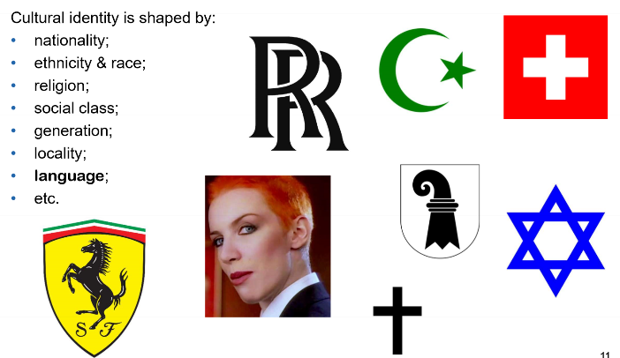

Examples
- Shibboleth mispronounciation since the Ephramites could not pronounce it right (that certain sound)
- Malta: promoting the use of Maltese created a Maltese national identity apart from Italian
- Yugoslavia: Serbo-Croatian was the official language. After the end of the republic Serbs and Croats both insisted their language being quite distinct
- New Zealand: embracing Maori culture, despite best intentions accused of cultural appropriation

Oxford English Dictionary “Cultural appropriation”:
“A term used to describe the taking over creative or artistic forms, themes, or practices by one cultural group from another. It is in general used to describe Western appropriations of non-Western or non-white forms and carries connotations of exploitation and dominance. The concept has come into literary and visual art criticism by analogy with the acquisition of artefacts (the Elgin marbles, Benin bronzes, Lakota war shirts, etc.) by Western museums.

Culture, language and communication are closely linked. The way in which we communicate or speak is shaped by our cultural background. It..
- dictates the topics that are talked about and the way in which they are talked about
- defines the taboos ant the boundaries of what is culturally acceptable, like swearing, sarcasm or irony
- influences the use of terms of address and names
- salutations
- greetings
- mannerisms
- formulaic phrases
- idioms & idiomatic phrases (it’s raining cats and dogs outside)
- hand gestures, body language (Italian “mamma mia” gesture)

SW2 – Eskimo words for snow
Sapir-Whorf Hypothesis: a hypothesis, first advanced by Edward Sapir in 1929 and subsequently developed by Benjamin Whorf, that the structure of a language determines a native speaker's perception and categorization of experience.

SW3 – Case study: Business in China
- As we have seen, Guanxi is an integral part of doing business in China. The term is ambivalent in that it carries the negative connotation of corruption and nepotism, as well as the positive connotation of building relationships on a foundation of trust and respect. In as much, Guanxi is also a mechanism that is used to exert social control – Guanxi is reciprocal and an abuse of Guanxi is likely to have consequences for all parties.
- The four businessmen clearly should have done their homework before going off to China to meet their prospective customer. It would have helped for them to request for an agenda and an expected outcome of the meeting. Like that, they would have perhaps not been so focussed on getting a contract signed by the Chinese businessman. Having said that, the client should also have prepared better for the meeting. Page 6 / 7/
- Essentially, the Chinese businessman was trying to build a relationship of trust with the four Westerner, and this was done by giving them what he thought would be a good time. The four businessmen felt uncomfortable by the many personal questions they were asked. Hutchings and Weir mention China’s “overt reverence for history”. If they’d known, it probably would have helped the Westerners to brush up their knowledge of their own country’s history. That would have defused the situation and created a common ground, based on a common interest. While at the same time it would have prevented them from having to answer a whole load of awkward questions.
- So, the big question is, how could this train wreck of a meeting between these four Westerners and the Chinaman have been avoided? Some students have suggested trying to explain to the host that his behaviour was making them feel uncomfortable. Which is probably true but not likely to achieve a useful result. The implicit accusation of such a statement being that it’s the Chinaman’s fault that they are not feeling comfortable.
- The best way to deescalate and avoid an intercultural conflict is to formulate statements that are directed inwards, so towards the speaker themselves – and not the listener. Thus, the speaker can avoid the impression that they are putting the blame on the listener. This is what perspectivising is all about, which is explained in the lecture on intercultural communication. So how about explaining to the Chinese businessman: “Look, I’m very much aware of how important trust is in doing business in China. And that is something I really appreciate. As you already know, I’m married. Because you already met my partner. Our relationship is based on trust, so I’m sure you can appreciate that do not want to abuse that trust.”

SW3 – Guanxi & Wasta

What are Guanxi and Wasta networks?
Both have the positive connotation of networking and the negative connotation of corruption.
Guanxi is a relationship between two people expected, more or less, to give as good as they get. A chinese individual with a problem, personal or organizational, naturally turns to his or her guangxiwang for assistance.
Wasta involves social networks of interpersonal connections rooted in family and kinship ties and implicating the exercise of power, influence, and information sharing through social and politico-business networks

Differences:
Guanxi | Wasta
refers to a business culture that is based on string family networks, underpinned by strong Confucian ethics. | refers to a social network in the Arab world that is also based on family networks and supported by Islamic ethics and values.

Advantages Guanxi
It has been further suggested that interpersonal connections and relationship networks have been particularly effective in overriding the bureaucratic loopholes of China. […] Guanxi has added tremendous flexibility to doing business in a society where the alternative has been excessive bureaucracy or formal hierarchies.

Cultural Dimensions
Main characteristics of Chinese culture using Hofstede’s cultural dimension’s model (2001)
- highly collectivist society
- high on the masculine scale (women are members of the workforce, but rarely in managerial positions)
- high on the power/distance index
- low-context societies
- overt reverence for history and tradition

SW4 – Intercultural Competence
Intercultural competence is an important sub-category of communicative competence. In corporate culture it has a lot to do with professional socialisation. Requires specific soft skills:
- increased awareness of situations/ physical symptoms signalling potential problems
- capacity to be tolerant, open to unfamiliar perspectives
- capability of self reflection, adjusting flexibly to different, unexpected situations

Darla Deardorff’s Process Model of Intercultural Competence (2006)
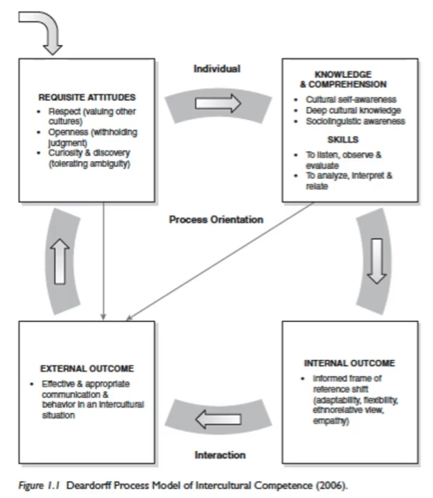
Requisite Attitudes  needed by individual, which will allow them or enable them to become intercultural culturally competent | Knowledge Comprehension Skills  are necessary in order to become into culturally competent combination of knowledge comprehension skills and prerequisite attitudes
External Outcome  describes how an individual will adapt their own communicative style in their interaction with people from different cultural backgrounds. | Internal Outcome  describes the changes in perception that an individual will experience

Dimensions Model
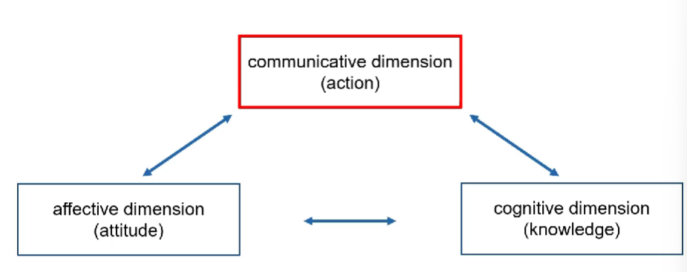
There are three dimensions that have an impact on how we become interculturally competent. The first is the communicative dimension which describes our interactions our actions and transactions with people from other cultural environments this is the dimension that we are focusing on in this semester in this lecture then there is the affective dimension which describes our attitudes towards other cultures and people from other cultural backgrounds and then there is the cognitive dimension which focuses on the knowledge and skills that we need to acquire in order for us to be competent in dealing with people from other cultural backgrounds when we say or do something we're always communicating or conveying something at the same time when we perform a communicative action we do so out of our own interest but also because we are acting towards a common goal together with the person towards which our communication is directed and that then is what we can describe as interaction and communication verbal trigger prompts a reaction or response from our interlocutor this can be done either verbally nonverbally or by action interacting is complex even if it's in a first for own language because it requires us to watch listen perceive and then correctly interpret to understand and to respond accordingly all of this processing becomes infinitely more complex if we are having to do it in a foreign or second language because it relies on a common understanding the purpose of the interaction and how it is expressed or encoded in language the purpose of communication is always based on the assumption of the need to achieve mutual intelligibility and this is achieved through a series of reciprocal interaction sequences known as turn taking however in a professional setting with interactions from different cultural backgrounds hold the assumption of mutual intelligibility for example because the underlying conventions of turn taking may be different from one cultural setting to another as we already saw invalid doodles process model of intercultural competence attitudes play a very important role in the process of becoming intercultural competence the term attitude has a broader meaning here though effective relates to all kinds of mental states moods and emotions such as disapproval or evaluation hit the affective dimension of the dimensions model of intercultural competence attitudes are affected in that they are based on subconscious mental process of evaluation and categorisation that influence how we feel about others and how we subsequently behave towards them attitudes are also shared professionally in occupational networks and groups in this case we speak of communities of practise communities of practise are based on long term professional networks of professionals collaborating on specific tasks to achieve a common objective overtime the members of the community practise will develop a group sense of belonging they will also develop their own communicative style which may be difficult for outsiders to understand for example in radiotelephony communication there is an overarching agreement among members of the community of practise that safety is the top priority in air traffic controller to pilot interaction as a result all other aspects of communication such as relationship building or politeness are not a priority finally the cognitive dimension in the dimensions model of intercultural competence is probably the one that is easiest to grasp it comprises knowledge of one's profession of different languages varieties of communication as well as knowledge of regional differences and cultural specifications that we can acquire these are parts of intercultural competence where learning is most likely to have an impact that is what we're going to try to focus on in this lecture finally I would like to point out that the arrows between the three dimensions that we have looked at are all double ended to suggest that they are reciprocal in the sense that they interact on each other to better explain the cognitive dimension I would like to use another example from aeronautical radio telephony communication on the radio telephony frequency it is important to keep messages as short as possible furthermore there are strict guidelines that dictate how a transmission shall be structured in as much as the first example you will see here is a pretty standard transmission that you are likely to hear on the radio telephony frequency Ty at 6-4 X behind company Airbus a 350 runway 16 line up behind however if you are not a pilot nor an air traffic controller so in other words if you are not a member of this community of practise then you perhaps will find this transmission and beat up big Louis a bit confusing and altogether very unclear in plain English we are more likely to say something along the lines of tier 648 wait until the tiger Airbus a 350 has landed and then enter the runway 16 the advantage of being member of this particular community of practise and knowing what the knowledge and skills are that are required of pilots and air traffic controllers means that we can make much shorter transmissions that are still effective and efficient.

SW5 – Intercultural Communication

Pragmatic models
Pragmatics refer to the study of how meaning is jointly created by the speaker and the listener. As such, pragmatics take into consideration many socio-cultural factors: meaning is derived from the time, place and manner of an utterance. In other words, meaning is created through interaction.

Semiotics
In contrast, there are also semiotic models. Semiotics deal with the way in which an object is represented in language through association. That is why semiotic models are less suitable for use in intercultural communication – because they require a priori knowledge that cannot be taken for granted.
Example: birdy bird, people already have an image of a bird in their head when someone tells them about a birdy bird.

Jochen Rehbein
“Intercultural communication is the mediation of cultural differences between social groups though verbal or nonverbal interaction. This kind of bridgeover requires specific techniques necessary for creating the participants’ mutual understanding”
In this definition, intercultural communication does not only occur between members of different nationalities or language groups, but also between different cultural groups within one society. Even if they use the same language.
This interpretation also postulated that intercultural communication can only happen if you are willing to raise into question your own cultural assumptions and their limitations – by relating to the person you are interacting with.
If we accept that intercultural communication can be difficult between members of different cultural groups, even if they speak the same language, we can only assume that multilingualism only adds complexity to any situation. And this is an big issue in most international settings.
Most commonly, intercultural communication research focusses on the investigation of instances of miscommunication and the analysis of their outcomes.

Example:
An early study by Gumerz investigated perceptions of politeness by the canteen staff at Heathrow airport. Customers complained about the apparent rudeness of the canteen staff, who were mostly from South Asia.
- Their word choice was not problematic
- However, they thended to use intonation patterns that made questions sound like commands, which the native speakers found hostile, very rude and aggressive.
- In German and English, a question is either marked by changing the word order around, or by a rising intonation at the end of an utterance.
- However, questions are marked differently in spoken language. For example, Japanese and Arabic use question markers to indicate a question.
- “Some more gravy?”
We all have very strong expectations of how things should be presented to us, how to behave, phrase things and react. In our own language, we’re not aware of these cultural expectations we have. We take them for granted. That is because we learn how to communicate within our own language.
As a result, we rely on behavioral patterns that are linked to social conventions persistent in our own cultural background. We do not realise there are differences in different cultures

Perspectivising
Perspectivising is a method that uses characteristics of special perspective to create intercultural discourse: space, standpoint, and aspect.
The speakers create understanding by relating differing cultural standards to each other verbally:
- by generalizing: one speaker generalises knowledge of a theme as a cultural standard. They then verbalise that cultural standard for the hearer to create a common ground (space).
- by perspectivising: the speakers relate to a different standpoint of the hearer. They veralise the listener’s standpoint to their own standpoint.
- by contrasting: the speaker connects the differing standpoints as sharing a common ground while representing separate aspects.

SW6 – The etic & emic approaches to intercultural studies
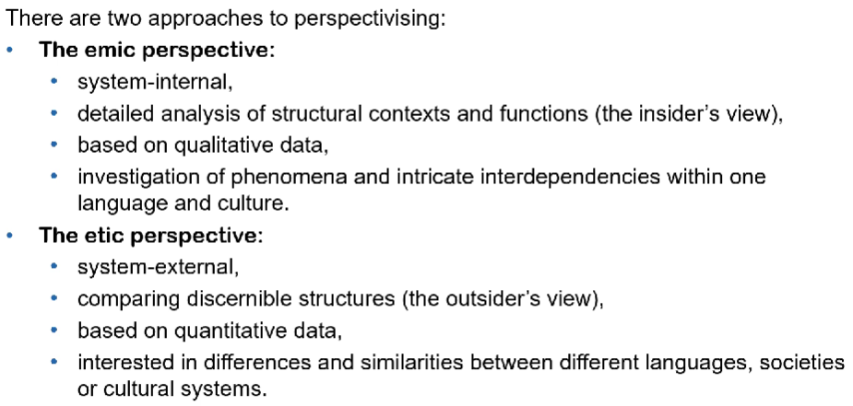

Example
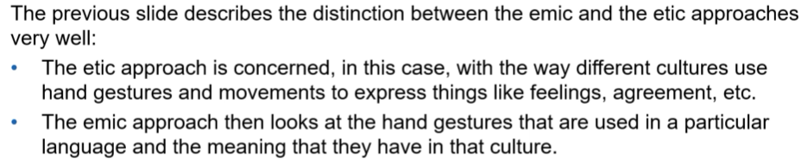
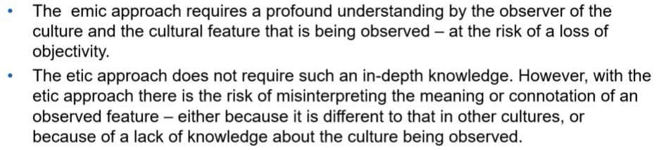
In intercultural communication research, the emic and etic approaches are not mutually exclusive. On the contrary, they complement each other very well as a means of obtaining a wider perspective of culture.
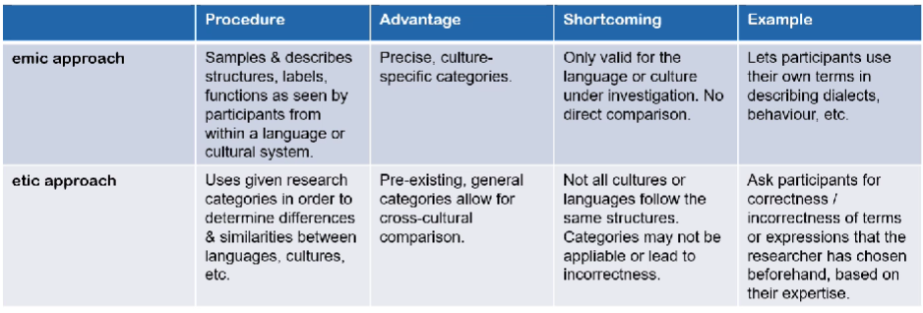

SW7 – Intercultural Challenges

?

