Marketing
Defintion
- Attract and retain customers at a profit, putting the right product in the right place at the right price and at the right time.
- Involves many parts of a company
- Marketing isn’t equal to communication
  - Goal Marketing: sales, market share, revenue, growth talk about benefits of a product
  - Goal Communication: Image, trust, reputation
Marketing Objects:
- Consumer Goods Marketing: products of private use (food, clothes, …)
- Capital Goods: products for operational use (Stadler rail, machines, …)
- Service: intangible assets and services(travel, health insurance, …)
- Non-Profit: non-profit organizations (WWF)
- Social: Social Idea creating awareness ( plastic in the ocean)
- Destination: specific region (Region Zurich, Zermatt, …)
- Trade: trading company retail trade (eg. Zalando, Amazon: don’t promote single products but the company itself)
Sales Markets:
- B to B: Business to Business car manufacturer purchases steel
- B to C: Business to Customer: business sells products to end user H&M
- C to C: Customer to Customer: individuals transact directly Airbnb
Market Analysis:
- Collection, processing, analysis of data about markets, competitors, …
- Market share: sales turnover of the company in relation to the total market volume
- Market volume: actual turnover of all suppliers on the market
- Market potential: number of potential customers
- Market capacity: total number of possible customers
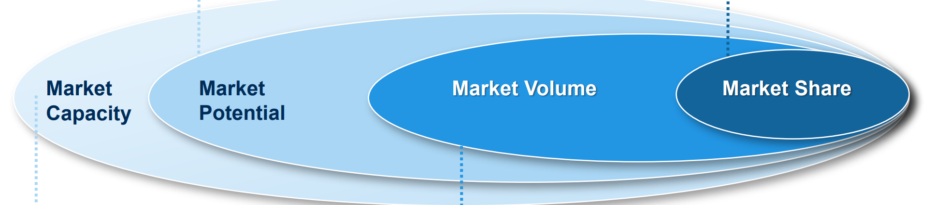
- Collecting Data:
  - Primary Data: surveys, questionnaires, observation
    - +: exclusive data, specific, accurate
    - - : expensive, needs time
  - Secondary data: Internet records, market reports, newspaper
    - + : faster, cheaper
    - - : not specific, competition has same data, not always available
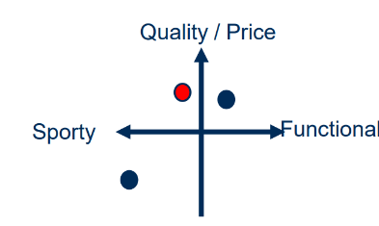
Marketing Strategy:
- Segmentation: dividing markets into smaller groups with the same needs
- Targeting: selecting the target segments
- Positioning: developing possible concepts
Segmentation criteria:
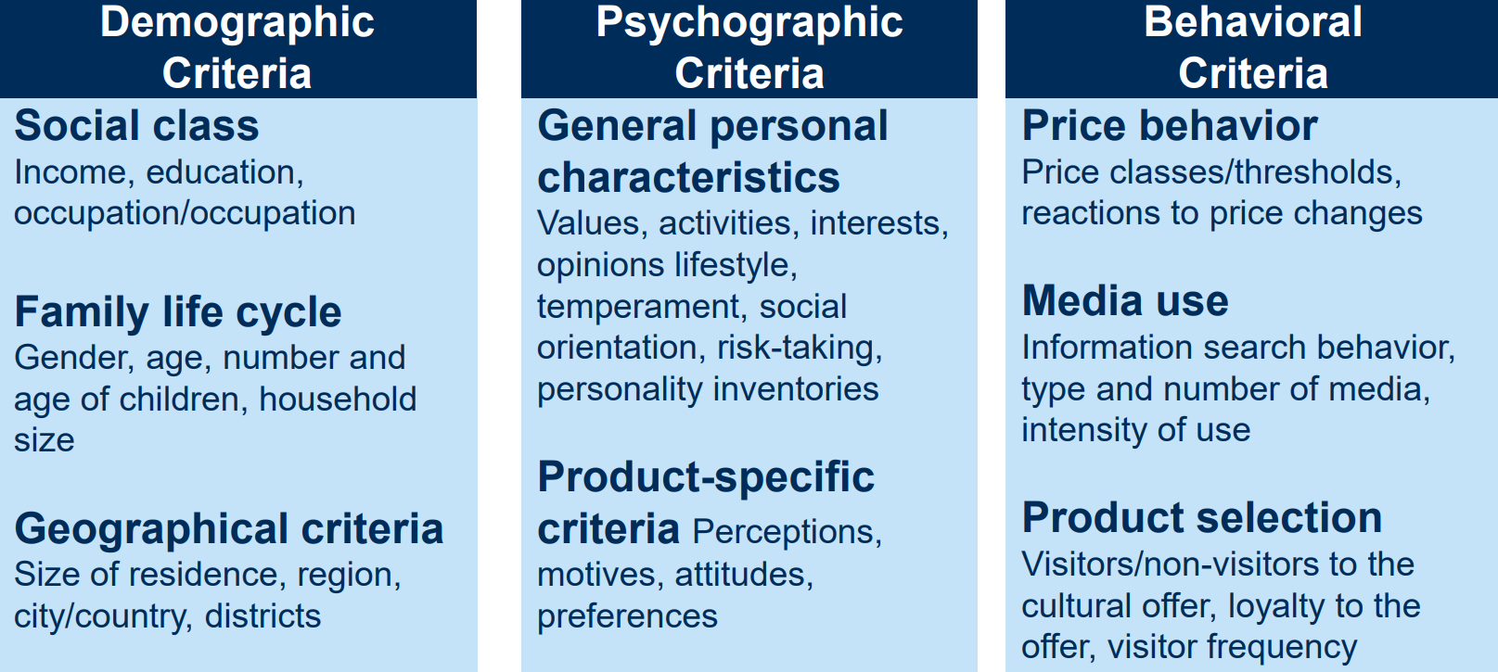
Requirements of effective Selection:
- Measurability: availability of data on customers can you measure?
- Substance: number of potential customers
- Accessibility: how to reach the customer
- Separability: heterogeneity to other segments
- Economic viability: benefit>cost
- Durability: target exists more than a year
- Problem of hybrid customers: buys cheap stuff but also expensive hard to segment
Marketing Mix
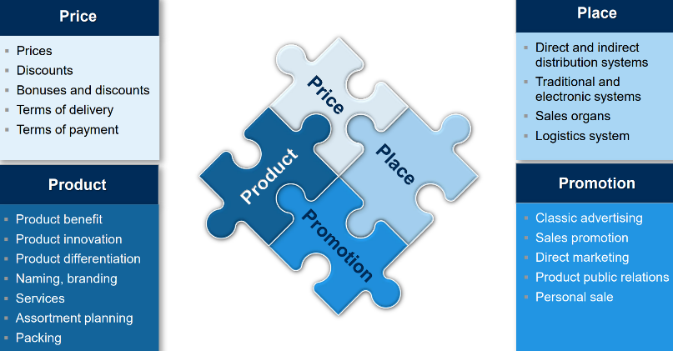
- Product:
  - Customer doesn’t buy a product but a benefit
  - Product Life Cycle: use variations of a product to extend life cycle and increase sales
  - Core product: show the core benefits
  - Formal product: brand name, features, design, packaging
  - Extended product: After-sales experience, delivery, warranty

- Promotion:
  - Customer decision journey
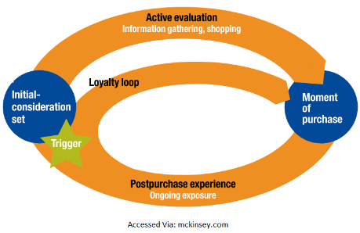
  - PESO Model:
    - P: Paid media digital advertising: YT ads, banners, Remarketing
    - E: Earned: Online PR media relations, influencer,
    - S: Shared: Social Media, Partnerships
    - O: Owned: Digital Properties: Apps, Catalogues
  - Marketing Concept:
    - Mission, Money, Message, Media, Measurement
  - Advertising Messages:
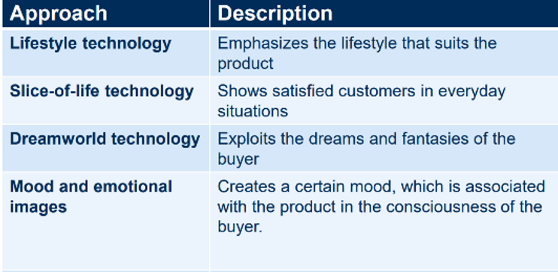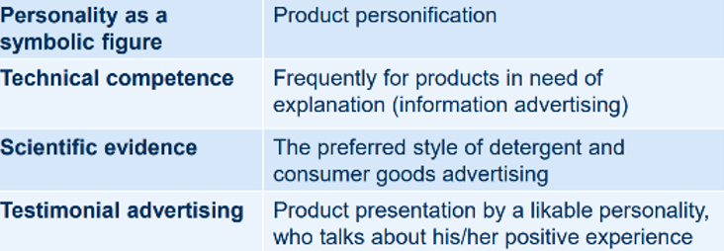

- Place:
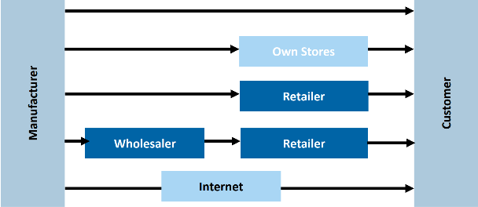
  - Distributions channels

  - Single Channel: one contact point, eg. Small corner shop
  - Multi Channel: numerous contact points (internet, shops)
  - Cross Channel : channels work together (eg. Click&collect)
  - Omni Channel: merging of channels, switching between channels, consistenst info and identification of customers Netflix
- Price:
  - Customer oriented prices: demand response to price changes
    - Temporal: eg. Day and night
    - Spatial: domestic and international
    - Group of buyers: student rates, discounts
    - Purchase quantity: volume discounts
    - Skimming: high launch prices for new technologies
    - Penetration: low introductory prices: food, printer
    - 19.95 instead of 20.00
    - Free offers: apps
    - Usage behaviour: cheaper the longer the subscription
  - Cost oriented: determination of the lower price limit break-even analysis
  - Competition oriented: competitive reactions
From 4 P to 7 P:
- Physical Facilities: nice smell, wifi, couches in Starbucks
- People: person is relevant, eg. Hairdresser
- Processes: making burgers, checking into a Hotel
Control/Evaluation:
- PDCA: Plan, Do, Check, Act
- Monitoring activities to ensure that results are in line with a plan
- Quantitative parameters: sales, market share
- Qualitative: customer satisfaction, image

